**IT-140 Design Document Template**

Jared Baker – July 31st 2022

**Storyboard**

Your spaceship was hit by debris and has split in half! You can see the escape pod drifting away, but you must get a full EVA suit in order to fly to it. You will need a spacesuit from the hallway, a helmet from your quarters, an oxygen tank from storage, an RCS module from the hangar, a battery pack from the armory, and finally the escape pod keys from the bridge. Once you have all the items, you will be able to exit the hull rupture in your ship and fly home. If you enter the unpressurized area unprepared, you will lose.

**Here is a map of ___ to help navigate your mission:**

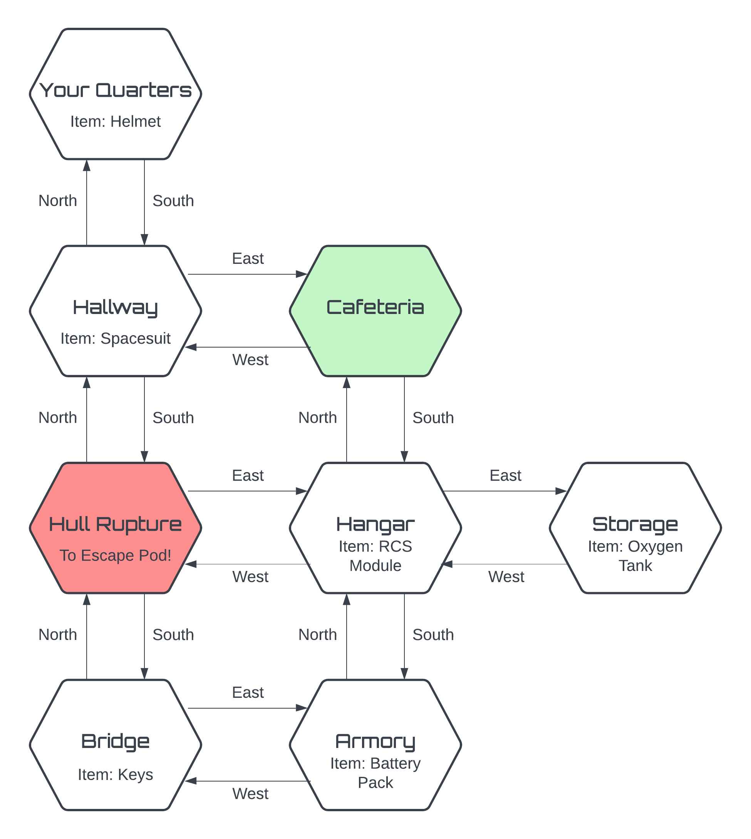

**Main Pseudocode**

SET current_room to ‘Cafeteria’

SET inventory to []

SET room_info to {‘ROOM NAME’: ‘ITEM NAME’, #FIXME for other rooms}

DEFINE INFO(current_room):

FOR current_room in room_info:

IF item == None:

break

ELIF item in inventory:

break

ELSE:

PRINT ‘You see a’, item

DEFINE PROMPT():

PRINT ‘You are in’, current_room

PRINT inventory

INFO()

DEFINE ACTION():

PRINT ‘-------------------------------’

SET user_input to INPUT ‘Enter your action:’

SPLIT and LOWER user_input

SET action, object to user_input[0], user_input[1]

IF ‘go’ in action:

MOVE(object)

ELIF ‘get’ in action:

GET(object)

ELSE:

PRINT ‘Invalid Input!’

PRINT Introductory message & Instructions

WHILE current_room != hull_rupture:

PROMPT()

ACTION()

PRINT Newline

ELSE:

PROMPT()

IF inventory in item_list:

PRINT Congrats you won message

ELSE:

PRINT Oh no you died/lost message

PRINT Thanks for playing!

**Pseudocode to “Move Between Rooms”**

DEFINE MOVE(direction, room=current_room):

IF current_room == ‘Cafeteria’:

IF direction == ‘north’:

PRINT ‘You can’t go that way!’

ELIF direction == ‘south’:

current_room = ‘Hangar’

ELIF direction == ‘east’:

PRINT ‘You can’t go that way!’

ELIF direction == ‘west’:

current_room = ‘Hallway’

ELIF #FIXME for all other rooms

**Pseudocode to “Get an Item”**

SET item_list to (spacesuit, helmet, rcs, oxygen, battery, keys)

DEFINE GET(item):

IF item in item_list:

IF item in inventory:

PRINT ‘You already have that!’

ELIF item in current_room:

APPEND item to inventory

PRINT item, ‘retrieved!’

ELSE:

PRINT ‘Can’t get’, item + ‘!’

ELSE:

PRINT ‘Invalid Input!’